Launch two ec2-instances and connect it to a application load balancer, where the output traffic from the server must be an load balancer IP address
Objective:
Launch two EC2 instances and connect them to an Application Load Balancer (ALB). The outbound (output) traffic should originate from the Load Balancer’s IP address, showing that the ALB handles traffic routing.
Step 1: Create EC2 Instances
- Launch two EC2 instances .
- Configure inbound rules to allow HTTP (port 80 ).
- Allow inbound HTTP (80) from Load Balancer only, not public.
- Allow SSH (22) from your IP.
- In advanced → Install Apache
- Click → Launch instance
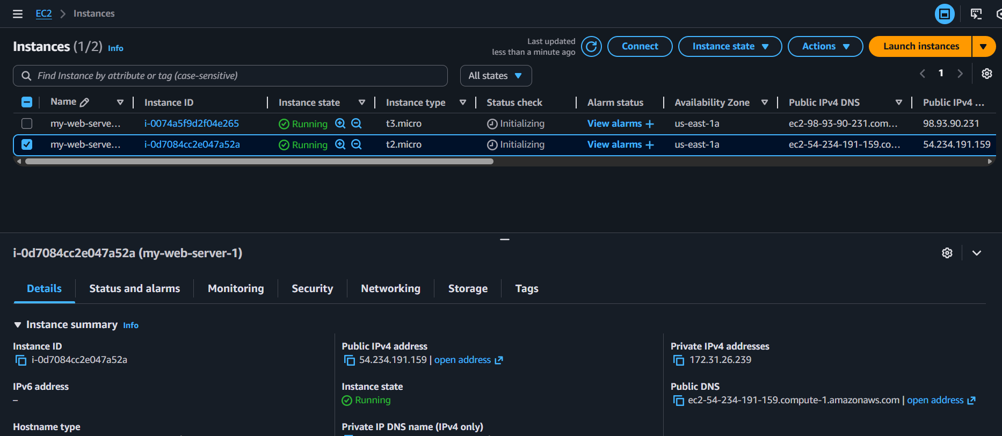
Step 2 : Create an Application Load Balancer (ALB)
- Navigate to EC2 → Load Balancers → Create Load Balancer → Application Load Balancer.
- Select 2 Availability Zones and subnets
- Allow Listeners and routing (port 80)
- Create or choose a target group.
- Register both EC2 instances as targets.

Target group:
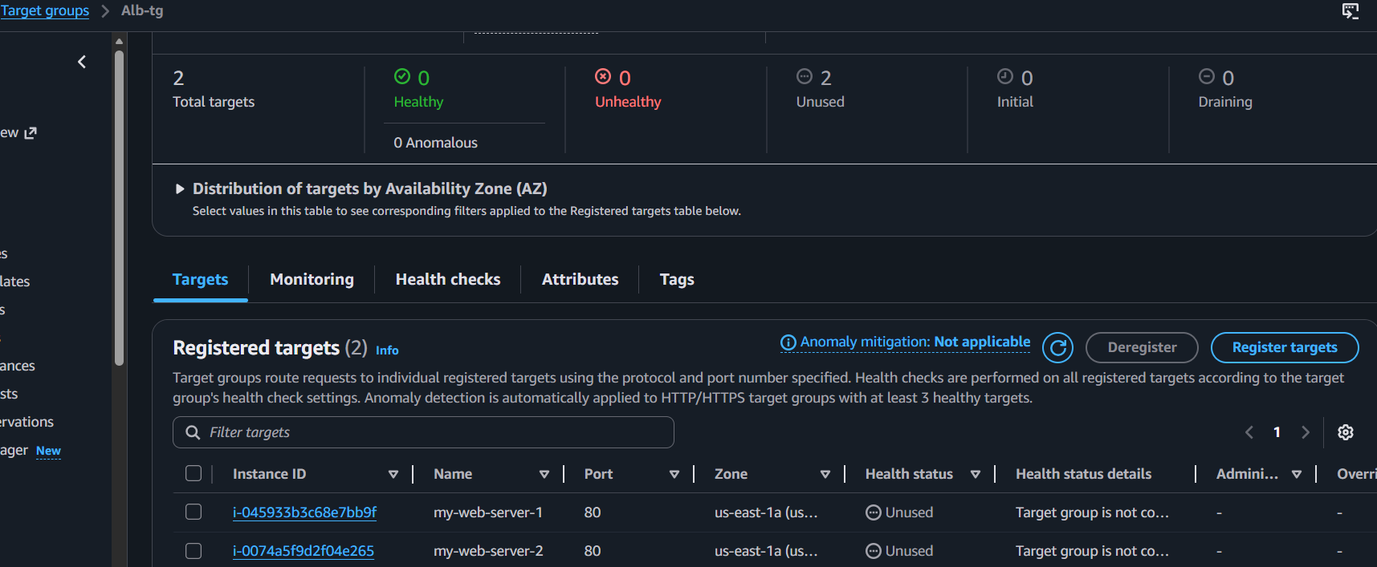
Load balancer:
